Computer Security Assignment

# P1

3 digit: 1000ms

4 digit: 10000ms

5 digit: 100000ms

6 digit: 1000000ms

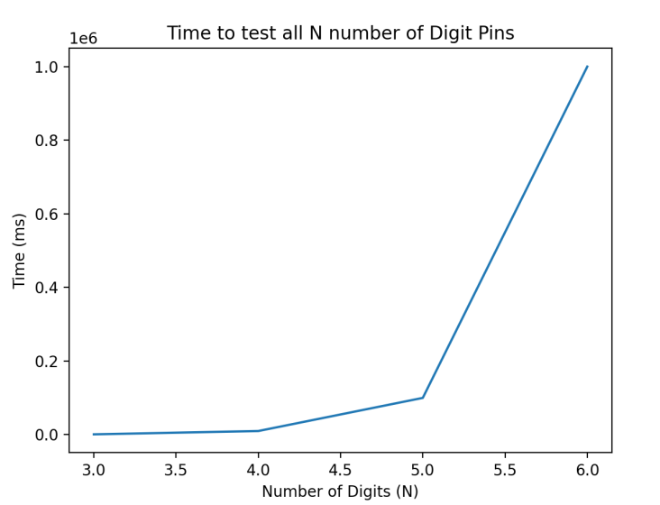

The formula is 10n with a time complexity of On.

# P2

For a 2 bit number:

1 challenge = 100% 4/4 unique integers left

2 challenges = 75% 3/4 unique integers left

3 challenges = 50% 2/4 unique integers left

4 challenges = 25% 1/4 unique integers left

5 challenges = 0% no unique integers left

As the number of challenges increases, the amount of unique integers remaining decreases. From this we can get a formula of 2n – (k-1) where n is the number of bits.

Using this formula we can plot k challenges for a 32 bit integer.

